# Lab Number: 02 Date:2025/06/13

# Title: Understanding the Ethernet Wiring in detail

# THEORY:

# Network Equipment Details

## Ethernet Cable:

First, a Cat5e Cable or Cat 6 cable will be required. This cable is mostly used while making an UTP (Unshielded Twisted Pair). Cat 5e is most common cable used in computer networking where number of twisted-pair wires are often grouped together and enclosed in a protective sheath to form a cable.

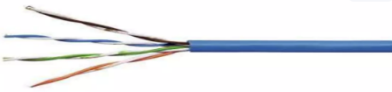

*Fig: Cable*

## Cable Stripper:

A cable stripper tool is used to remove the insulation safely, without exposing wired underneath.

**Use**: It ensures that wires are properly stripped without damaging wires.

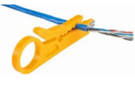

*Fig: Cable Stripper*

## RJ45 Connectors:

Now, we will need at least 2 RJ45 wire connectors. RJ45 is a standard type of connector for Ethernet network cables. It is an eight-wire connector used to connect computers to category 5 unshielded twisted-pair cables in a network.

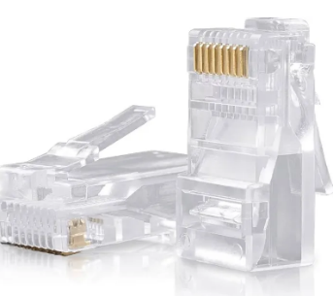

*Fig: RJ45 connectors*

## Wire Crimpers:

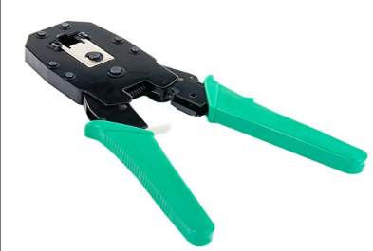After that, RJ45 wire crimpers are used to conjoin two pieces of metal by deforming one or both of them in a way that caused them to hold each other. It is used to crimp UTP cable to RJ45 connector

*Fig: Wire Crimpers*

## Cable Tester:

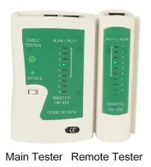 A cable tester is an electronic device used to verify the electrical connections in a cable or other wired. It ensures that cables are properly wired and can transmit data without any issues.

*Fig: Cable Tester*

# Wiring Details

# Straight Through:

A straight-through cable is a type of UTP network cable having eight wires, with each pair being twisted together used for connecting unlike devices. At each end, the same-coloured wire ends in both sides i.e. pin 1 at one end will always line up with pin 1 at the other end. Pin 2 connects to pin 2, and so on.

1. **Colour Code(T658B)**

There are 8 colour coded wires. These wires are twisted into 4 pairs of wires; each pair has a common colour theme. One wire with solid coloured wire while other being striped type.

Orange/White

Orange

Green/White

Blue

Blue/White

Green

Brown/White

Brown

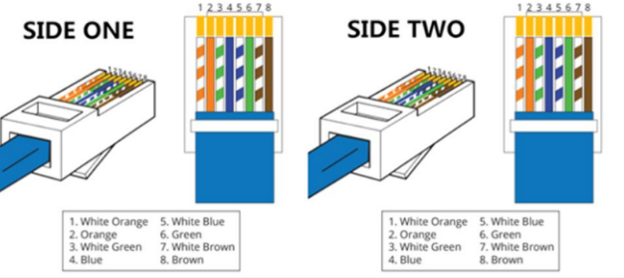

*Fig: Straight-Through Cable*

# Cross Over:

Crossover cables are used for connecting alike devices. It is used to cable devices such as switch to switch, hub to hub, Router Ethernet port to PC NIC, PC to PC, etc. Unlike straight through cable, the RJ45 crossover cable uses two different wiring standards: one end uses the T568A wiring standard and the other end uses the T658B wiring standard.

1. **Colour Code:**

The internal wiring of Ethernet crossover cables reverses the transmit and receive signals and the only difference with respect to straight cable is that 1st and 3rd // and 6th numbered cables are swapped on 2nd end of the cable

|  |  |  |
| --- | --- | --- |
|  | **Side One(T568A)** | **Side Two(T568B)** |
| Pin 1. | Green/White | Orange/White |
| Pin 2. | Green | Orange |
| Pin 3. | Orange/White | Green/White |
| Pin 4. | Blue | Blue |
| Pin 5. | Blue/White | Blue/White |
| Pin 6. | Orange | Green |
| Pin 7. | Brown/White | Brown/White |
| Pin 8. | Brown | Brown |

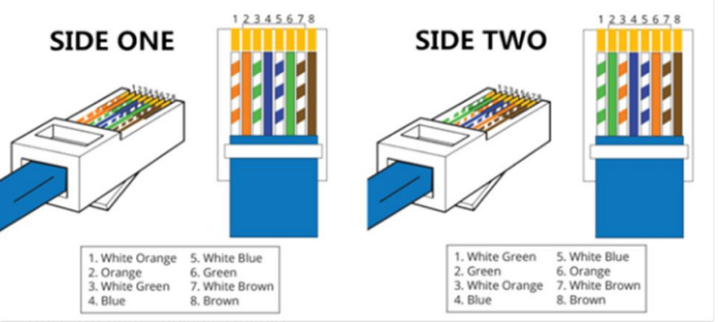

*Fig: Crossover cable*

# Steps Required to Construct

**Straight Through:**

1. Prepare all the materials required.
2. Carefully remove the outer jacket of the cable.
3. Untwist the pairs and arrange the wires based on Straight-Through wiring.
4. Trim the untwisted wires to a suitable length.
5. Keep the wires flat and in order as you push them in to the RJ-45.
6. Place the wired plug into the crimping tool.
7. Repeat all the steps with the other end of the cable.
8. Test the cable using the Cable Tester.

**Cross Over:**

1. Prepare all the materials required.
2. Carefully remove the outer jacket of the cable.
3. Untwist the pairs and arrange the wires based on Cross-Over wiring.
4. Trim the untwisted wires to a suitable length.
5. Keep the wires flat and in order as you push them in to the RJ-45.
6. Place the wired plug into the crimping tool.
7. Repeat all the steps with the other end of the cable with T-568A standard if the first end was done with T-568B.
8. Test the cable using the Cable Tester.

Conclusion:

In this practical, we understood the concepts of STRAIGHT-THROUGH and CROSSOVER UTP LAN Cabling structure, along with their respective colour coding and the purpose of different equipment used in LAN cabling. We build and tested both types of UTP cables using the correct wiring standards and tools. The learnings emphasized the importance of precise cabling techniques, providing a solid foundation for future networking projects and troubleshooting.